**9th March 2016**

**YOKOHAMA returns as Title Sponsor of LPGA Tournament in Alabama**

Top players expected to play in the 2016 Yokohama Tire LPGA Classic, May 5-8 at the RTJ Golf Trail at Capitol Hill in Prattville

SANTA ANA, CA. – For the third consecutive year, Yokohama Tire Corporation (YTC) is teeing it up with the Ladies Professional Golf Association (LPGA) in Prattville, Alabama. That’s where the 2016 Yokohama Tire LPGA Classic will be held May 5-8 on the Senator Course at Capitol Hill along the Robert Trent Jones (RTJ) Golf Trail.

Long-time tournament veteran Kris Tamulis is expected to return to the 2016 Yokohama Tire LPGA Classic to defend her championship title, along with top players Stacy Lewis, Michelle Wie, Cristie Kerr, Yani Tseng, Ayako Uehara and Brooke Henderson.

The tournament, traditionally held in late summer, has been moved to Mother’s Day weekend to enable LPGA golfers to participate in the Rio Summer Olympics. Currently, nearly half of the potential Olympians for women’s golf (representing 18 countries) are in the 2016 Yokohama Tire LPGA Classic field.

“We’re glad the Olympic committee has recognized golf and these tremendous athletes,” said Alan Holtschneider, YTC director of marketing. “The Yokohama Tire LPGA Classic will be a great way for the golfers to prepare for the Olympic Games, which should make for an exciting, competitive environment.”

The 2016 Yokohama Tire LPGA Classic will once again benefit, KaBOOM!, a national non-profit dedicated to ensuring that all children get the balanced and active play they need to thrive. Proceeds from the tournament will help fund building another new playground for kids, like the one YTC and KaBOOM! built in Southern California in 2015.

**About the Robert Trent Jones Golf Trail**

Funded by the Retirement Systems of Alabama, the Robert Trent Jones Golf Trail was built to help expand tourism, recruit industry and attract retirees, thus strengthening the state’s economy while adding to the quality of life for all Alabamians. The RTJ Golf Trail opened in 1992 and has welcomed more than 11 million rounds of golf. From Mobile Bay to the Tennessee River, the RTJ Golf Trail has 26 courses on 11 sites across Alabama.

**About the LPGA (Ladies Professional Golf Association)**

The LPGA is the world’s leading professional golf organization for women. Founded in 1950, the association celebrates a diverse and storied membership with more than 1,700 members representing 29 different countries. With a vision to inspire, empower, educate and entertain by showcasing the very best of women’s golf, LPGA Tour Professionals compete across the globe, while dedicated LPGA Teaching and Club Professionals (T&CP) directly impact the game through teaching, coaching and management. The Symetra Tour consistently produces a pipeline of talent ready for the world stage. The LPGA is headquartered in Daytona Beach, Florida. Follow the LPGA on its television home, Golf Channel, and on the web via: [www.LPGA.com](http://www.lpga.com/), [www.twitter.com/lpga](http://www.twitter.com/lpga), and [www.youtube.com/lpgavideo](http://www.youtube.com/lpgavideo).

**About Yokohama Tire Corporation**

Yokohama Tire Corporation is the North American manufacturing and marketing arm of Tokyo, Japan-based The Yokohama Rubber Co., Ltd., a global manufacturing and sales company of premium tyres since 1917. Servicing an extensive sales network throughout the U.S., Yokohama Tire Corporation is a leader in technology and innovation. The Company’s complete product line includes tyres for high-performance, light truck, passenger car, commercial truck and bus, and off-the-road mining and construction applications.

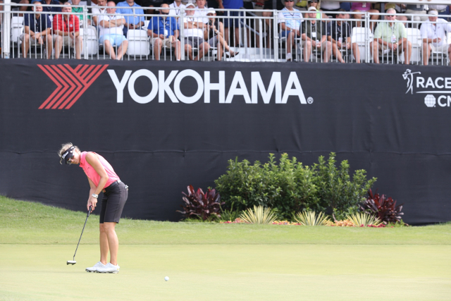

*2015 Champion Kris Tamulis on 18th green*